ONLINE CELL PHONES
SHOPPING

Submitted By: M.Sayyad.Ali
Roll No:
Submitted To: Sir Salman Khan
Computer Instructor
GTVC GUJRAT MARDAN

DIT THESIS 2021
GTVC Gujrat,
MARDAN
APPROVAL SHEET

Accepted for partial fulfillment of the
DIPLOMA IN INFORMATION TECHNOLOGY (D.I.T)
KHYBER PUKHTUNKHWA BOARD OF TECHNICAL
EDUCATION PESHAWAR
Internal Examiner______________________________
Remarks _________________________________
Signature _________________________________

External Examiner______________________________
Remarks _________________________________
Signature _________________________________



DEDICATION

DEDICATED TO MY PARENTS, TEACHERS AND
ALL OUR COLLEGUES.

First of all I am so grateful to almighty ALLAH who with his grace gave me the chance to complete this task successfully.
I thankfully wish by our heart and great feeling regards for sake of respectable supervisor.
Mr. Salman Khan for his help, support and courage in the completion of this task.
M.Sayyad.Ali

Project Briefing

Project Title: Online Cell Phone Shopping
Institute NAME: GTVC Gujrat, Mardan
Designed By: M.Sayyad.Ali
Starting Date: 20/02/2021
Completion Date: 04/03/2021
Source Used: Intel, Core 2 duo
Operating System: Window 7

Software USED:
- NOTEPAD
- DREAMWEAVER
- GOOGLE CHROME BROWSER
- MICROSOFT WORD

HTML
DEFINITION:
HTML Stands for hypertext markup language. The format, or the language used in the WEB is called hypertext markup language.
Explanation:
HTML is the set of special instruction called tags or markup that are used to specify document structure, formatting, and link to other document.
Important Points:
- An HTML file is a text containing small markup tags .The markup tags tells the WEB browser how to display the page.
- An HTML file must have an htm or html file extension.
- An HTML file can be created using a simple text editor.
Creating First HTML document:
IF you are running Windows, start Notepad. Type the following text:
<html>
<head>
<title>Title of page</Title>
</head>
<body>
This is my First Homepage. <b>this text is bold</b>
</body
</html>
Save the file as “mypage.htm” OR Save the file as “mypage.html”.
Preview in Browser:
Start Your Inter browser. Select “Open” in the file menu of your browser. A dialog box will appear. Select “Browse and locate the HTML file you just created – (“mypage.html”). and click Open. Your File will be on the display screen
HTML DOCUMENT STRUCTURE:
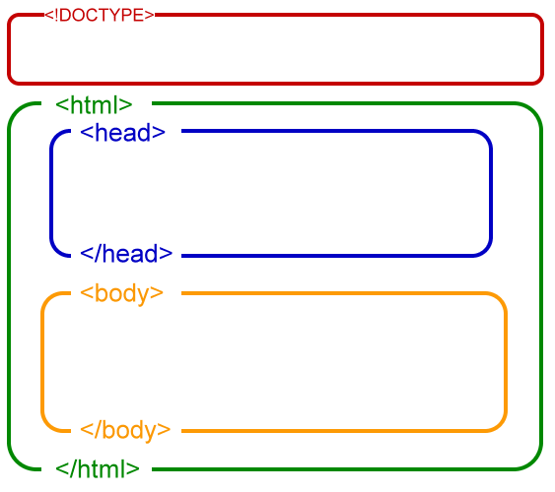
- HTML TAG: The First tag in your HTML document is <html>. This tag tells your browser that this is the start of an HTML document.
- HEAD TAG: The text between the <head> tag and the </head> tag is header information. However information is not displayed in the browser window.
- TITLE TAG: The text between the <title> tags is the title of your document. The title is displayed in your browser caption.
- BODY TAG: The text between the <body> tags is the text will be displayed in your bowser.
- LAST TAG: The last tag is the closing of each Opening tag e.g: </html>
HTML TAGS:
DEFINITION:
An HTML tag is a signal to a browser that it should do something other than just throw text up on the screen. By convention all HTML tags begin with and open angle (“<”) and ends with a close angle braces (“>”).
TAGS APPLICATIONS:
- HTML Tags are used to mark-up HTML elements.
- HTML Tags are surrounded by two characters<and >
- The surrounding characters are called angle brackets
- HTML Tags always come in Pairs e.g.: <b></b>
- The first tags will be start tags and another will closing tag
- Elements between tags are the elements context.
- HTML Tags are not case sensitive.

HTML HEADINGS:
HTML has also heading attributes. Which are followingas?

- HEADING 1: The initial and most biggest heading in the html is h1
Example:GTVC GUJRAT
- HEADING 2: The Second heading and small in size than first one is h2
Example:GTVC GUJRAT
- HEADING 3: The Third heading is smaller in size than second and first.
Example:GTVC GUJRAT
- HEADING 4: The fourth heading is smaller in size than third>>.
Example: GTVC GUJRAT
- HEADING 5: The fifth heading is smaller than fourth and >>>.
Example: GTVC GUJRAT
- HEADING 6: The last heading is h6 it is smaller in size heading.
Example:GTVC GUJRAT
INTRODUCTION TO XHTML:
Following are the major Point of XHTML.
IMPORTANT POINTS:
- XHTML Stand for Extensible Hypertext Markup Language
- XHTML is almost identical to HTML.
- XHTML is a stricter and cleaner version of HTML.
- XHTML is HTML defined as an XML application.
- XHTML is supported by all major browsers.
XHTML ELEMENTS:
Following are the elements of XHTML.
- XHTML elements must be properly nested.
- XHTML elements must always be closed.
- XHTML elements must be in lowercase.
- XHTML elements must have one root elements.
XHTML ATTRIBUTES:
XHtm have some Attributes which are following as.

- Attributes names must be in lower case
- Attributes values must be quoted
- Attributes minimization is forbidden.

Example : <option selected > WRONG
<option selected=”selected” CORRECT
XHTML DIFFER FROM HTML:
- XHMTL DOCTYPE is mandatory.
- The XML namespace attribute in <html> is mandatory.
- <Html>, <head>, <title>, and<body> is always mandatory.

Project source codes:
<!DOCTYPE html PUBLIC "-//W3C//DTD XHTML 1.0 Transitional//EN" "http://www.w3.org/TR/xhtml1/DTD/xhtml1-transitional.dtd">
<html xmlns="http://www.w3.org/1999/xhtml">
<head>
<meta http-equiv="Content-Type" content="text/html; charset=iso-8859-1" />
<title>Untitled Document</title>
<style type="text/css">
<!--
.style2 {font-family: "Script MT Bold"}
.style5 {
font-size: 50px;
color: #9933CC;

}
.style6 {font-family: Arial, Helvetica, sans-serif}
.style8 {font-family: Arial, Helvetica, sans-serif; font-size: 24px; color: #990099; }
.style12 {
font-family: Arial, Helvetica, sans-serif;
font-size: 14px;
color: #000000;
font-weight: bold;
}
.style13 {
font-size: 24px;
color: #FF6600;
}
.style15 {font-family: Arial, Helvetica, sans-serif; font-size: 36px; color: #FF0066; font-weight: bold; }
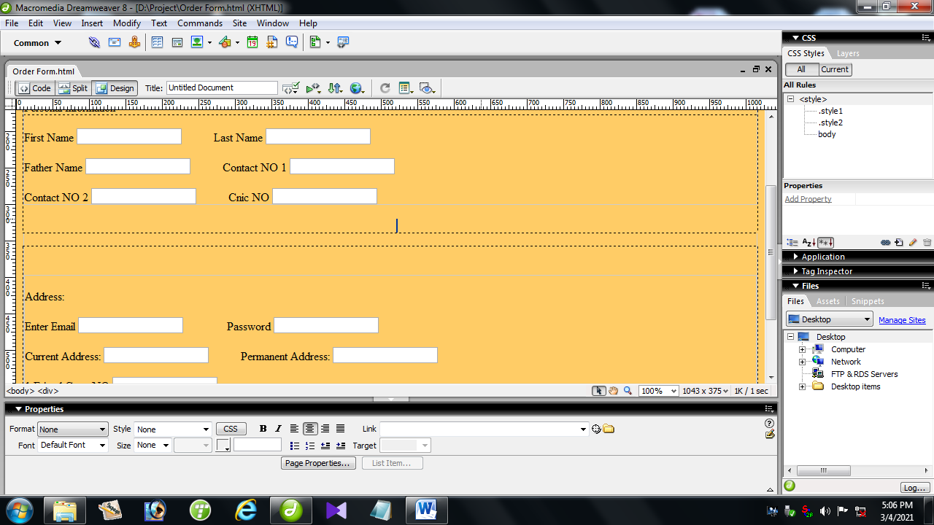

.style16 {
font-size: 36px;
color: #FF33CC;
font-weight: bold;
}
.style17 {
font-family: Arial, Helvetica, sans-serif;
font-size: 24px;
font-weight: bold;
color: #CC6633;
}
.style18 {font-family: Arial, Helvetica, sans-serif; font-size: 18px; font-weight: bold; color: #333333; }
.styl
e19 {

font-family: Arial, Helvetica, sans-serif;
font-size: 36px;
font-weight: bold;
color: #003333;
font-style: italic;

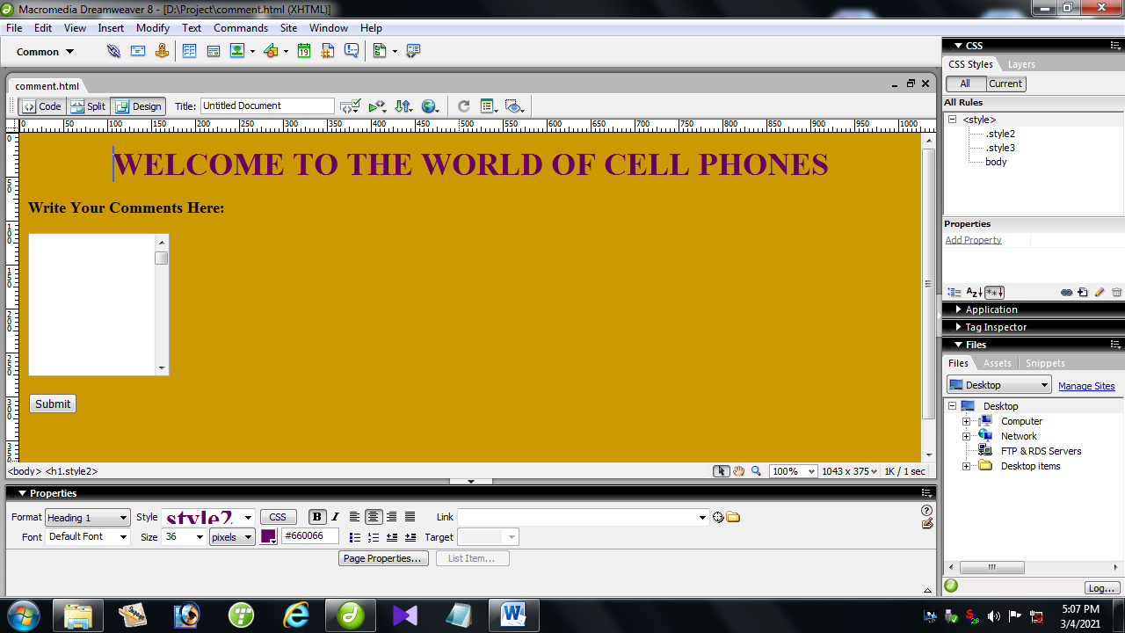
}
.style20 {font-family: Arial, Helvetica, sans-serif; font-size: 18px; font-weight: bold; color: #3366FF; }
body {
background-color: #99FF33;
}
-->
</style>
</head>

<body>
<h1 align="center" class="style2"><span class="style5">Online Cell Phones Shopping</span></h1>
<p align="center" class="CASES stylelOWE style13"><strong>Every Type of Phones Are Available Here. </strong></p>
<p align="left" class="CASES stylelOWE style13">&nbsp;&nbsp;&nbsp;&nbsp; &nbsp;&nbsp;&nbsp;&nbsp;&nbsp;&nbsp;&nbsp;&nbsp;&nbsp;&nbsp;&nbsp;&nbsp;&nbsp;&nbsp;&nbsp;&nbsp;&nbsp;&nbsp;&nbsp;</p>

<h4 align="left" class="style8">Preface:</h4>
<p align="left" class="style12">By Using This Site You Can able To Buy Old Phones ,New Phones, Phones In Less Price, Expensive Phones and You Can Also Buy Parts of Phones Likes:</p>
<table width="514" height="39" border="0">
<tr>
<td width="73">Batteries</td>
<td width="71">Handfree</td>
<td width="68">Chargers</td>
<td width="116">Internet Devices </td>
<td width="164">Cover and Glass </td>
</tr>
</table>
<p align="left" class="style15">Cell Phone Type: </p>
<h5 align="left" class="style6">Select Your Choice from the Given list:</h5>
<table width="978" height="35" border="0">
<tr>
<td width="227"><a href="Old Fashion Phone/old fashion phone.html">Old Fashion Phones</a></td>
<td width="206"><a href="Second Hand Phones/Second Hand Phones.html">Mid Class Phones</a></td>
<td width="254"><a href="touch ponn/touch pone.html">Touch Screen Phones </a></td>
<td width="273"><a href="Special Variety/Special variety.html">Special Variety Phones </a></td>

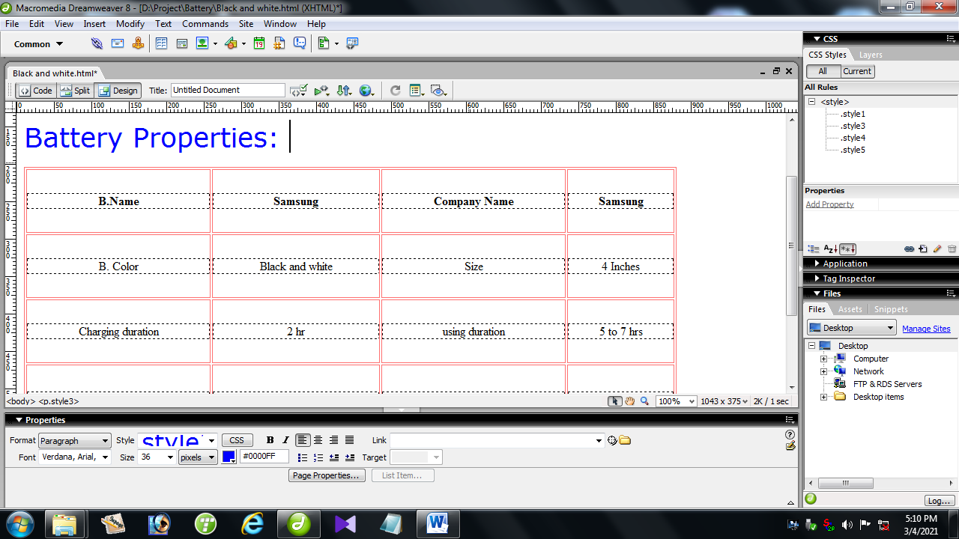
</tr>
</table>
<p class="style16">Cell Phone Parts:</p>
<p>Select Your Choice From the Given List. </p>
<table width="989" height="38" border="0">
<tr>
<td><a href="Battery/Battery 1.html">Batteries</a></td>
<td><a href="Blutooth Devices/Blutooth Devices.html">Blutooth Devices </a></td>
<td><a href="Internet Devices/Internet Devices.html">Internet Devices </a></td>
<td><a href="Handfrees/Handfrees.html">Handsfree and Headphones </a></td>
<td><a href="Pouches& glass/Pouches.html">Pouch and Glass </a></td>
<td><a href="Displays/Displays.html">Displays</a></td>
</tr>
</table>

<p>&nbsp;</p>
<p>&nbsp;</p>
<p class="style17">End Request: </p>
<table width="597" height="153" border="1" bordercolor="#0033CC">
<tr>
<td bordercolor="#993300" bgcolor="#0099FF"><span class="style18">If you like our site and found that it is useful then appreciate us and write your expressions about our site. Otherwise if you don't like our site and found borren or not correct then also write your expression.</span></td>
</tr>
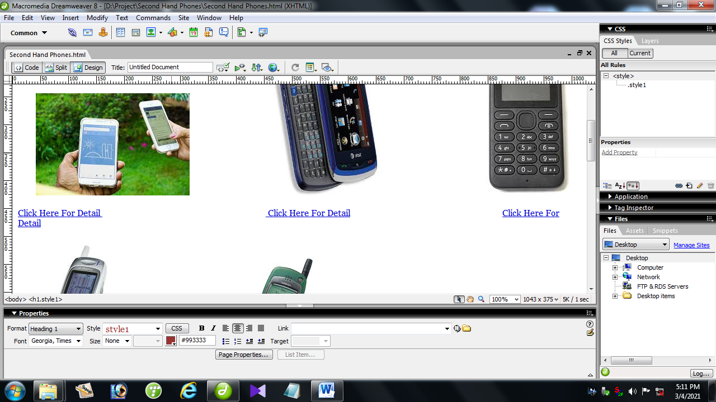
</table>
<p class="style20"><a href="comment.html">Write Comments </a><a href="../comment.html"></a></p>
<p align="center" class="style19">Thanks.</p>
<label></label><p>&nbsp; </p> </body>

- FINAL RESULT
