Project 6 – Word Processing (MS Word)

Project Objective
To communicate efficiently and to remain competitive, it is essential for a company to create documents. You will use Microsoft Word to create letters and labels to send to your customers from your Access database.

Project Overview
This project has been organized into 4 different parts:
- Create a letter from a template
- Merge data from an Access database
- Create return labels
- Create customer labels

This project has been organized into 4 different parts:
- header.png from Lab3
- lastname_firstname_access.accdb from Lab5

You will create the following files:
- lastname_firstname_customers.docx
- lastname_firstname_labels.docx
- lastname_firstname_letters.docx
- lastname_firstname_word.docx

Part 1 – Create a Letter

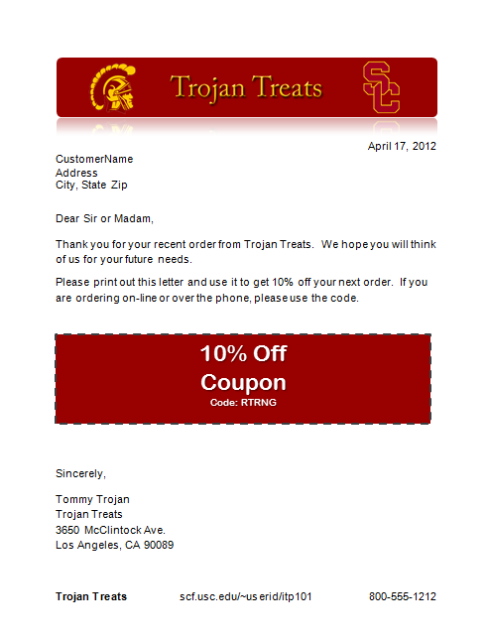
In part 1, you will create a letter to send out to your customers. Follow the instructions listed below.
- On your flash drive (or on your computer), create a folder named lastname_firstname_lab6
where lastname and firstname are replaced with your information.
- Download the ITP101_Lab6.dotx file from Blackboard, and put it in your lab6 folder.
- Make sure the header.png file that you used for your Dreamweaver lab (Lab3) is also on the flash drive (or on your computer).
- Put your lastname_firstname_access.accdb file from your Access lab (Lab5) in your lab6 folder.

Open Microsoft Office Word 2010.
- From the top, click on the File tab. Click on the New option.
- From the Available Templates section, select the New from existing option.
- In the New from Existing Document window, select the ITP101_Lab6 template file in the lab6
folder and click the Create New button.

File Properties:
- From the top, click on the File tab. Click on the Info option.

- Under the Properties section, change the Title to your company name. Change the Tags to

coupon.
- Under the Related People section, click on Add an author and type in your name.
- Click on the Save icon (floppy disk). In the Save As window, browser to the lab6 folder. For the File name, enter lastname_firstname_word. For the Save as type, make sure that Word Document is selected. Click on the Save button.

Image:
- Click on the Trojan Treats image and press the Delete key.
- Click on the Insert tab, and click the Picture option.
- Browse to your header.png file and click the Insert button.
- With your image selected, click on the Format tab and change the Picture Style. Date:
- Click under the image and click on the Insert tab. Click on the Data & Time option and
select a date (not time). Click the OK button.
- Select that date and use the Home tab to right justify it.

Message:
- Edit the message of the letter to include your company name.
- Click on the “Coupon” and the Format tab. Change the Shape Fill to a color that matches your header image but is not black. If you want to use a light color, then change your font color to a dark color.
- At the bottom of the letter, change the EmployeeName to your name. Update the company name and address.
- Update the font and font size to your liking using the Home tab.

Footer:
- Click on the Insert tab, click on the Footer pull-down, and select the Three Columns
option.
- For the first section of the footer, enter your company name. Change the font by using the
Home tab.
- In the second section of the footer, enter your company’s web address, which is the one you used for the Dreamweaver lab (Lab 3). It should be scf.usc.edu/~userid/itp101 where userid is replaced with your USC username.
- In the third section of the footer, enter a phone number. This can be a fabricated number.
- Click on the Design tab. Make any other changes you want. Click on the Close option.
- Save your file.

Part 2 – Importing data from an Access database
In part 2, you will merge data from your Access database in order to make a group of letters. Follow the instructions and samples listed below.
- From the top, click on the Mailings tab. Click on the Start Mail Merge option and select the Step by Step Mail Merge Wizard… option from the pull-down. The wizard will appear in a panel on the right side.
- In the Mail Merge panel for the type of document, select the Letters radio button. At the bottom of the panel, click on the Next: Starting document link.
- For the starting document, select the Use the current document radio button. Click on the

Next: Select recipeints link.
- For the recipients, click on the Browse… link in order to select your list from your Access database.
- In the Select Data Source window, browse and find your Access database file and click the
Open button.
- In the Select Table window, select the CustomersTbl and click the OK button.
- In the Mail Merge Recipients window, use the Find duplicates… link to make sure you do not include any duplicates. Click the OK button.
- Back in the Mail Merge panel, click on the Next: Write your letter link.
- Match CustomerName to the Access database:
  - In your letter, select the text CustomerName without selecting the carriage return (i.e., line break or new line). (Here’s a trick: to select the line/sentence without the carriage return, hold down the control key and click on the line/sentence.)
  - In the Mail Merge panel, select the More items… link.
  - In the Insert Merge Field window, make sure that the Database Fields radio button is selected and click on the CustomerName field. Click on the Insert button. Click on the Close button.
- Repeat this process for the Address, City, State and Zip. You should see << and >> surrounding each word in the letter.
- In the Mail Merge panel, click on the Next: Preview your letters link.
- To preview your letters, click on the << and >> buttons in the Mail Merge panel. Then click on the Next: Complete the merge link.
- To complete the merge, click on the Edit individual letters… link which will merge the letters into one document.
- In the Merge to New Document window, make sure the All radio button is selected. Click the
OK button.
- You now have a Word document with a page for each customer. Save this document as
lastname_firstname_letters.docx.
- Back in the lastname_firstname_word.docx file, close the Mail Merge panel and save.

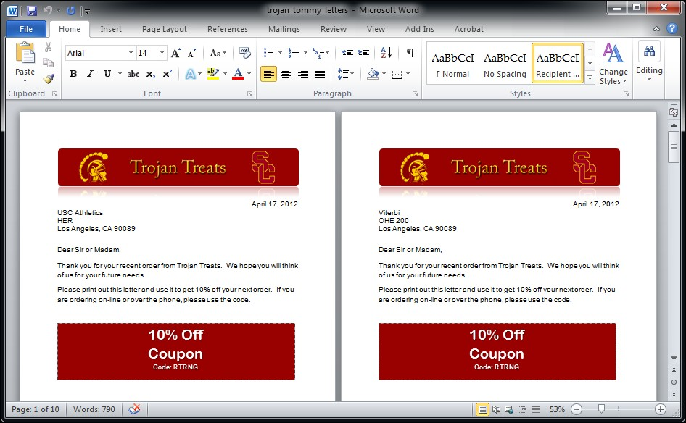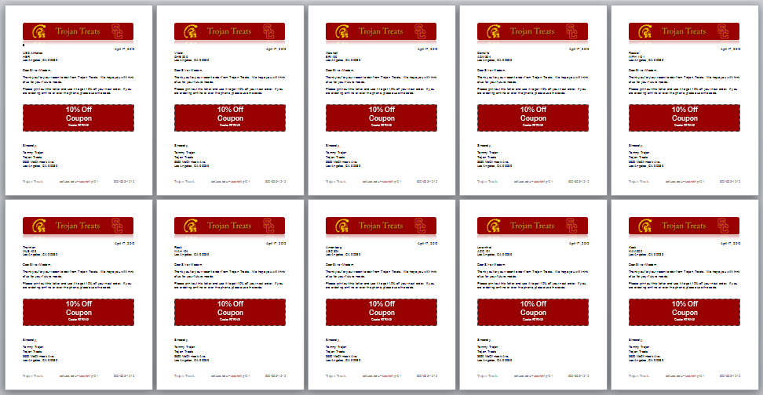

Part 3 – Create Return Labels
In part 3, you will create return labels.
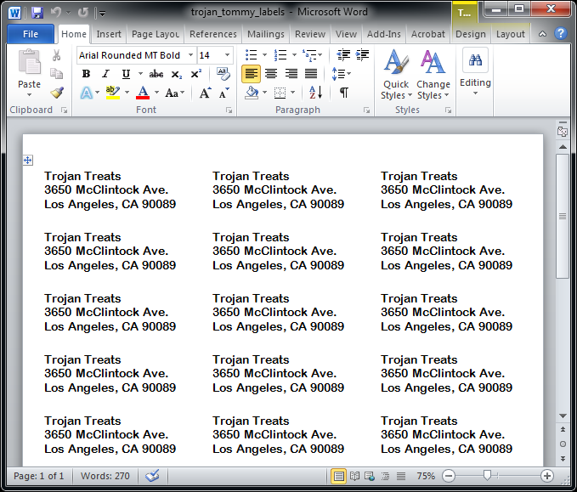
- Click on the Mailings tab and then click the Labels option.
- In the Envelopes and Labels window in the Address text area, make sure it has your company name and its address. Do not have it include your name.
- For the Print option, make sure the Full page of the same label radio button is selected.
- Click on the Options… button.
- In the Label Options window, select the Microsoft option for the Label vendors pull-down. For the Product Number, select the 30 Per Page option with the following Label information: Height
= 1”, Width = 2.63”, Page size = 8.5” x 11”. Click the OK button.
- Back in the Envelopes and Labels window, click the New Document button.
- Select all of the labels by clicking on the 4 arrows icon in the upper left corner. Change the font.
- Save this document as lastname_firstname_labels.docx.

Part 4 – Create Customer Labels
In part 4, you will create labels for your customers.
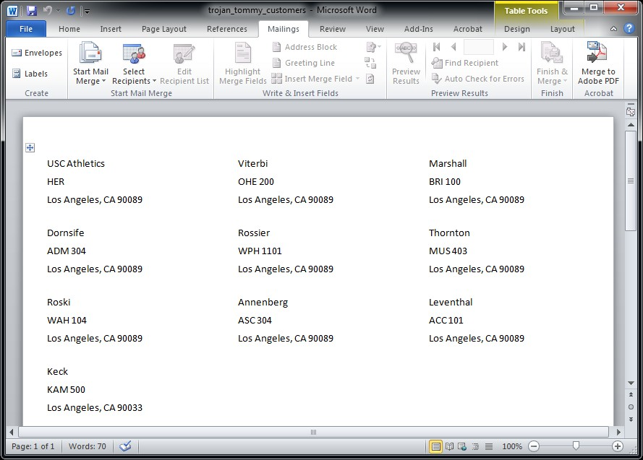
- Create a new file by selecting the File tab and clicking on the New option.
- Select the Blank document options and click on the Create button.
- Click on the Mailings tab.
- Click on the Start Mail Merge pull-down and select the Labels… option.
- In the Label Options window, select the Microsoft option for the Label vendors pull-down. For the Product Number, select the 30 Per Page option with the following Label information: Height
= 1”, Width = 2.63”, Page size = 8.5” x 11”. Click the OK button.
- Click on the Select Recipients pull-down and select the Use Existing List… option.
- In the Select Data Source window, browse and find your Access database file and click the
Open button.
- In the Select Table window, select the CustomersTbl and click the OK button.

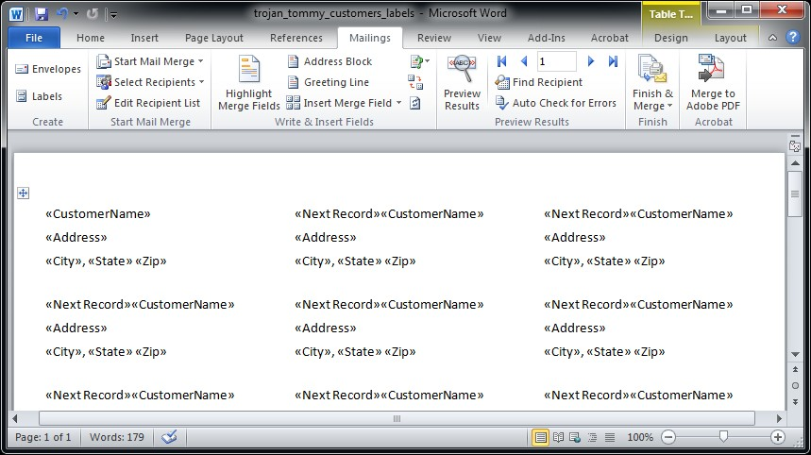
- Add a merge field for the CustomerName:
  - Click on the Insert Merge Field pull-down and select CustomerName option.
  - Press the return key to add a carriage return.
- Add merge fields for the Address, City, State, and Zip. Put the City, State, and Zip on one line with a comma after the City.
- Click the Update Labels option to have it repeat the merge fields for all of the labels.
- Click the Finish & Merger pull-down and select the Edit Individual Documents… option.
- In the Merge to New Document window, make sure the All radio button is selected. Click the
OK button.
- Save this document as lastname_firstname_customers.docx.

Submitting the project
- Your lastname_firstname_lab6 folder should contain the following files: header.png, ITP101_Lab6.dotx, lastname_firstname_access.accdb, lastname_firstname_customers.docx, lastname_firstname_labels.docx, lastname_firstname_letters.docx, and lastname_firstname_word.docx.
- Use a zip program such as 7-Zip and zip them into one file named
lastname_firstname_lab6.zip. This is the file that you will submit on Blackboard.
- Submit your zip file on Blackboard (http://blackboard.usc.edu) under Assignments:
  - Click on the Lab6 assignment.
  - Next to Attach File, click on the Browse My Computer button.
  - Find your lastname_firstname_lab6.zip file and click the Choose button.
  - Click on the Submit button in the bottom right corner.

